* What is CDN?
* What is crossorigin?
* What is React.createElement ?

React.createElement (“h1”, {}, “Hello World from React”);

{} is the object where we can give attributes to our tag.

React.createELement gives us objects which contains props which goes inside our tag.

* What is ReactDOM.createRoot()

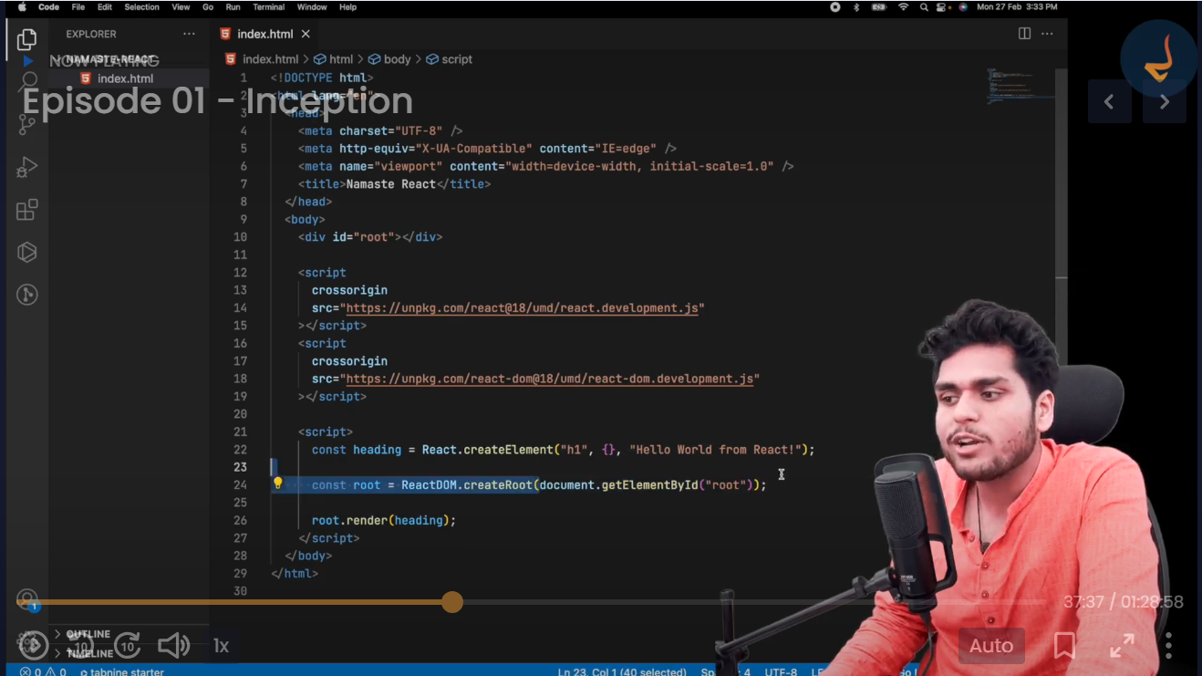

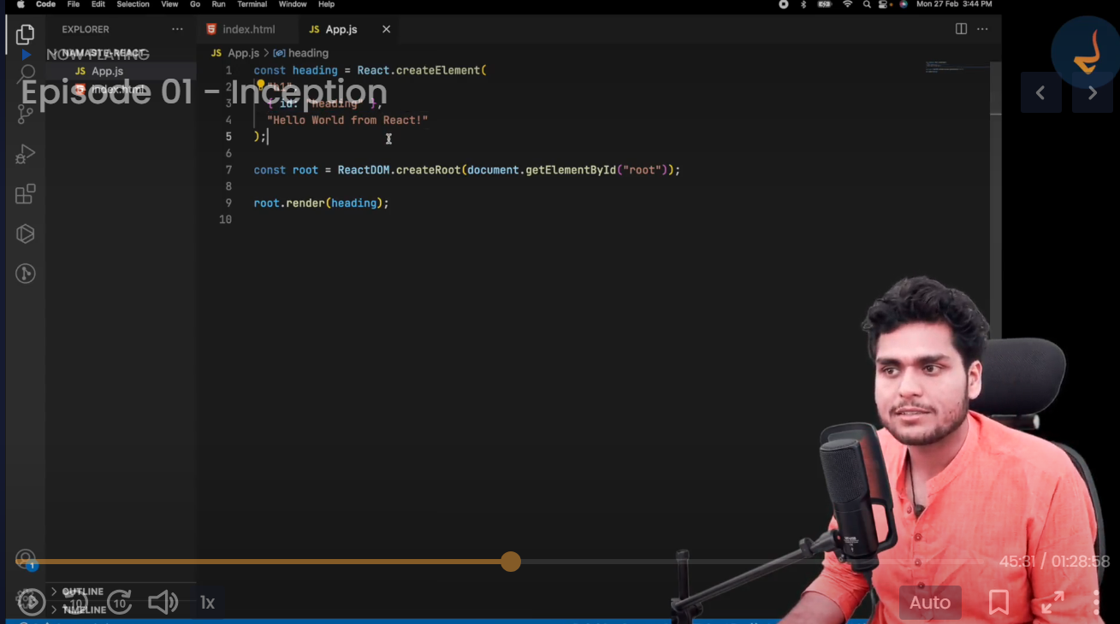

Render method is responsible to take the object returned from createElement and put it against our DOM.

We can use React.createElement to create a nested HTML structure also.

If we need to pass multiple children inside a parent HTML tag, we can pass an array to 3rd argument of React.createElement.

Add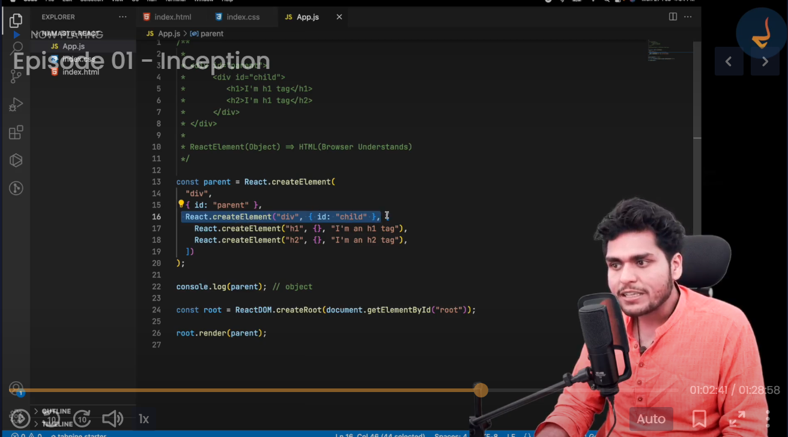



Whatever we have inside our root tag of HTML will be replaced with what we have passed from our render method.

* Package.json file is a configuration for npm.
* What is the job of a bundler? Webpack, Parcel, veet ?
* Create react app behind the scenes uses webpack and babel to build things up.
* There are 2 types of dependencies:

1. Dev Dependencies (used while development)
2. Normal Dependencies (used in production)

* What is the difference between ~ (tilde) and ^ (carat) signs in dependencies.
* What is the difference between package.json and package-lock.json ?
* What is transitive dependency?

npx parcel index.html

npx vs npm

npx means executing a package